**Internship Report**

**Kohinoor Energy Limited 124MW Diesel Power Plant**

**35-Km Link Manga Raiwind Road Lahore**

**M.Shamaas**

**Mshamaas1997@gmail.com**

**Overview**

This report summarizes my experience of the three-month internship in Kohinoor Energy Limited 124MW Power Plant. The work is very tortuous, dangerous, exhausting and stressful. The workers carry out very dangerous activities. They are exposed to high currents, heavy power tools and machinery, biohazards, poisonous chemicals, dark work areas, long and exhausting work shifts etc. The company takes great precautions to make sure that the workers do not face any physical harm. I got to see the things that I had studied in Electrical Engineering but never saw.

**Power Plant Block Diagram**

**Electrical System**

|  |  |  |
| --- | --- | --- |
| **1** | **DG-SET 1-8** | **D:\UET\UET\Kohinoor Internhip\Photos\ELECTRICAL\ENGINE HALL\DSC_0000564.jpg**  **D:\UET\UET\Kohinoor Internhip\Photos\ELECTRICAL\ENGINE HALL\DSC_0000675.jpg**  **D:\UET\UET\Kohinoor Internhip\Photos\ELECTRICAL\ENGINE HALL\DSC_0000514.jpg** |
| **2** | **Steam Turbine Generator 9** | **D:\UET\UET\Kohinoor Internhip\Photos\ELECTRICAL\ENGINE HALL\DSC_0000698.jpg** |
| **3** | **LV/DC Auxiliary System** | **D:\UET\UET\Kohinoor Internhip\Photos\ELECTRICAL\PANELS, DEVICES AND METERS\DSC_0000705.jpg**  **D:\UET\UET\Kohinoor Internhip\Photos\ELECTRICAL\PANELS, DEVICES AND METERS\DSC_0000706.jpg**  **D:\UET\UET\Kohinoor Internhip\Photos\ELECTRICAL\PANELS, DEVICES AND METERS\DSC_0000703.jpg** |
| **4** | **Transformers MT1, MT2, MT3** | **D:\UET\UET\Kohinoor Internhip\Photos\ELECTRICAL\TRANSFORMERS\MT3\DSC_0000221.jpg**  **D:\UET\UET\Kohinoor Internhip\Photos\ELECTRICAL\TRANSFORMERS\MT1\DSC_0000218.jpg** |
| **5** | **Transmission Grid** | **D:\UET\UET\Kohinoor Internhip\Photos\ELECTRICAL\GRID\DSC_0000381.jpg**  **D:\UET\UET\Kohinoor Internhip\Photos\ELECTRICAL\GRID\DSC_0000386.jpg** |
| **6** | **PLC System and Control Room** | **D:\UET\UET\Kohinoor Internhip\Photos\ELECTRICAL\ENGINE HALL\DSC_0000744.jpg**  **D:\UET\UET\Kohinoor Internhip\Photos\ELECTRICAL\CONTROL ROOM\DSC_0000231.jpg** |

**Common Fuel System**

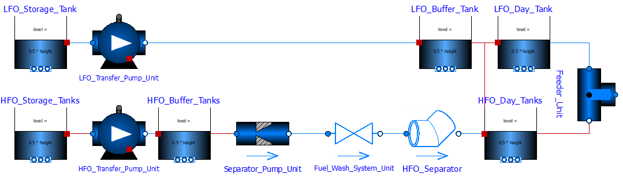

|  |  |  |
| --- | --- | --- |
| 1 | Fuel Decanting Shed | D:\UET\UET\Kohinoor Internhip\Photos\FUEL\DECANTING SHED\DSC_0000349.jpg  D:\UET\UET\Kohinoor Internhip\Photos\FUEL\DECANTING SHED\DSC_0000321.jpg    D:\UET\UET\Kohinoor Internhip\Photos\FUEL\TRANSPORT\DSC_0000286.jpg |
| 2 | HFO Storage Tanks | D:\UET\UET\Kohinoor Internhip\Photos\FUEL\STORAGE\DSC_0000285.jpg    D:\UET\UET\Kohinoor Internhip\Photos\FUEL\STORAGE\DSC_0000327.jpg |
| 3 | Transfer Pump Unit | D:\UET\UET\Kohinoor Internhip\Photos\FUEL\PIPES\DSC_0000416.jpg |
| 4 | Fuel Wash System Unit |  |
| 5 | Buffer Tanks and Day Tanks | D:\UET\UET\Kohinoor Internhip\Photos\FUEL\STORAGE\DSC_0000289.jpg |

**Booster System**

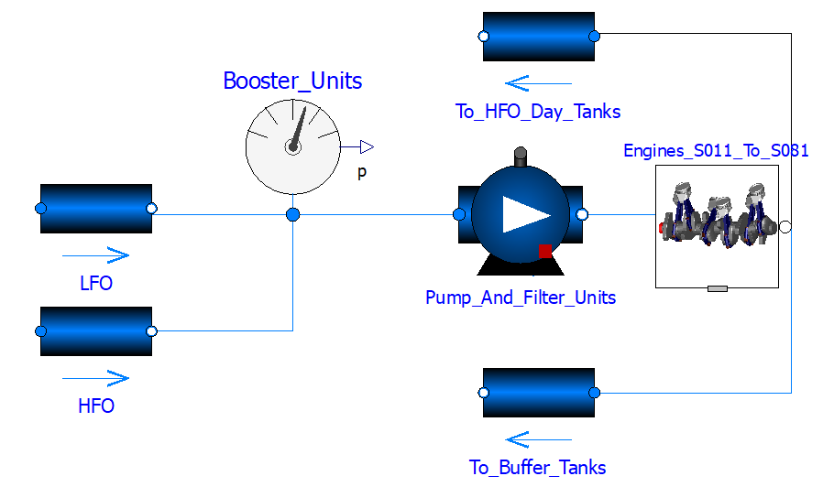

|  |  |  |
| --- | --- | --- |
| 1 | Booster Units | D:\UET\UET\Kohinoor Internhip\Photos\FUEL\PIPES\DSC_0000421.jpg |
| 2 | Fuel Pump and Filter Units | D:\UET\UET\Kohinoor Internhip\Photos\FUEL\PIPES\DSC_0000447.jpg |

**Common Sludge Oil System**

|  |  |  |
| --- | --- | --- |
| 1 | Sludge Water Tanks |  |
| 2 | Sludge Treatment Unit | D:\UET\UET\Kohinoor Internhip\Photos\FUEL\WATER\DSC_0000776.jpg  D:\UET\UET\Kohinoor Internhip\Photos\FUEL\WATER\DSC_0000790.jpg |
| 3 | Sludge Pits | D:\UET\UET\Kohinoor Internhip\Photos\FUEL\TRANSPORT\DSC_0000754.jpg |

**Common Engine Cooling System**

|  |  |  |
| --- | --- | --- |
| 1 | Engine Cooling System | D:\UET\UET\Kohinoor Internhip\Photos\FUEL\WATER\DSC_0000799.jpg  D:\UET\UET\Kohinoor Internhip\Photos\FUEL\WATER\DSC_0000775.jpg |

**Common Steam Turbine Cooling System**

|  |  |  |
| --- | --- | --- |
| 1 | Steam Turbine Cooling System | D:\UET\UET\Kohinoor Internhip\Photos\FUEL\WATER\DSC_0000799.jpg  D:\UET\UET\Kohinoor Internhip\Photos\FUEL\WATER\DSC_0000408.jpg |

**Common Water Treatment System**

|  |  |  |
| --- | --- | --- |
| 1 | Priming Tank |  |
| 2 | Pump House |  |
| 3 | Water Treatment Unit |  |
| 4 | Buffer Tank |  |
| 5 | Hydrophore Unit |  |

**Steam Heating System**

|  |  |  |
| --- | --- | --- |
| 1 | Trace Heaters |  |
| 2 | Settling Tanks |  |
| 3 | Condensate Water Pump Unit |  |
| 4 | Observation Tank |  |

**Starting Air System**

|  |  |  |
| --- | --- | --- |
| 1 | Starting Air Unit | D:\UET\UET\Kohinoor Internhip\Photos\FUEL\WATER\DSC_0000794.jpg |

**DG-SET Lube Oil System**

|  |  |  |
| --- | --- | --- |
| 1 | Lube Oil Separator |  |
| 2 | System Oil Tank |  |
| 3 | Lube Oil Pumps |  |
| 4 | Safety Filter |  |
| 5 | Gravity Tank |  |
| 6 | Lube Oil Storage Shed | D:\UET\UET\Kohinoor Internhip\Photos\FUEL\CHEMICALS\DSC_0000412.jpg |

**DG-SET Cooling System**

|  |  |  |
| --- | --- | --- |
| 1 | Cooling System |  |

**DG-SET Exhaust Gas and Charge Air System**

|  |  |  |
| --- | --- | --- |
| 1 | Exhaust Gas Boiler |  |
| 2 | Charge Air Filter Unit | D:\UET\UET\Kohinoor Internhip\Photos\FUEL\CHIMNEY\DSC_0000747.jpg |

**Steam Turbine Generator 9**

|  |  |  |
| --- | --- | --- |
| 1 | Steam Turbine Generator 9 |  |

**QEHS**

|  |  |  |
| --- | --- | --- |
| 1 |  |  |
| 2 |  |  |
| 3 |  |  |
| 4 |  |  |
| 5 |  |  |
| 6 |  |  |
| 7 |  |  |
| 8 |  |  |

**Devices, Machines and Tools**

|  |  |  |
| --- | --- | --- |
| 1 | Pumps: Rotary lobe pump, Progressive cavity pump, Rotary gear pump  Piston pump, Diaphragm pump, Screw pump, Gear pump, Hydraulic pump, Rotary vane pump, Peristaltic pump, Rope pump, Flexible impeller pump, Air Compressor. | Image result for air compressor  Image result for pump  Related image |
| 2 | Lathe Machine | Related image |
| 3 | Angle Grinder | Image result for side grinder |
| 4 | Alligator Shear | Related image |
| 5 | Air Blower | Related image |
| 6 | Miter saw, circular saw, cold saw | Image result for chop saw |
| 7 | Belt Sander | Image result for belt sander |
| 8 | Oscillatory Multi-tool | Image result for multi-tool |
| 9 | Nail Gun | Image result for nail gun |
| 10 | Needle Scaler | Related image |
| 11 | Pneumatic torque wrench | Related image |
| 12 | Pressure Washer | Image result for pressure washer |
| 13 | Sander | Related image |
| 14 | Drill | Image result for drill |
| 15 | Drill Machine | Related image |
| 16 | Heat Gun | Image result for heat gun |
| 17 | Vacuum cleaner | Image result for Vacuum Cleaner |
| 18 | Jigsaw | Image result for jigsaw tool |
| 19 | Hand Tools: Wrench, Plier, File, Screwdriver, Hammer, Vise, Snip, Knife, Clamp, Ratchet, Wire Stripper, Cable Cutter, Flashlight, Tape measure, Puncher, drill, nuts, nails, rasp, chisel, bits, sand paper, awl, nip. | Related image |
| 20 | 1. Relays: Electromagnetic attraction type relay, Induction type relay, Solid state relay, Numerical based/Microprocessor based relay, Hybrid Relay, Thermal overload relay, Insulation monitoring relay, Liquid monitoring relay, Gas actuating relay, Reed Relay. 2. Examples: Paralleling Relay, Under Reactance Relay, Over Voltage Relay, Under Voltage Relay, Under Frequency Relay, Over Frequency Relay, Differential Over Current Relay, Thermal Overload Relay, Earth Fault Relay, Excitation Loss Relay, Generator Protection Relay, Multimode Auxiliary Relay, PC Board Relay, Buchholz Relay. | Image result for relays |
| 21 | Circuit Breakers: Oil Circuit Breaker, Air Circuit Breaker, SF6 Circuit Breaker, Vacuum Circuit Breaker, HVDC Circuit Breaker, Miniature Circuit Breaker, Moulded case Circuit Breaker, Single Pole Circuit Breaker, Double Pole Circuit Breaker, Ground Fault Interrupter Circuit Breaker, Arc Fault Circuit Interrupter Circuit Breaker. | Related image |
| 22 | PLC | Image result for PLC |
| 23 | Mechanical Switches: Push Lock Switch, DIP Switch, Push-to-make Switch, Rocker Switch, Rotary Switch, Slide Switch, Tact Switch, Toggle Switch, Limit Switch, Float Switch, Flow Switch, Pressure Switch, Temperature Switch, Joystick Switch. | D:\UET\UET\Kohinoor Internhip\Photos\Picture Book\ELECTRICAL\CONTROL ROOM\DSC_0000231 - Copy.jpg |
| 24 | Electronic Switches: Bipolar Junction Transistor, Power Diode, Metal Oxide Semiconductor Field Effect Transistor, Insulated Gate Bipolar Transistor, Silicon Controlled Rectifier, Bidirectional Triode Thyristor, DIAC, JFET, Gate Turn Off Thyristor. | Image result for electronic semiconductor switches |
| 25 | Cables: Coaxial cable, Direct-buried cable, Flexible cables, Filled cable, Heliax cable, Non-metallic sheathed cable, Metallic sheathed cable, Multicore cable, Paired cable, Portable cord, Ribbon cable, Shielded cable, Single cable, Structured cabling, Submersible cable, Twin and earth, Twinax cable, Twin-lead, Twisted pair | Related image |
| 26 | Energy Meters: Electromechanical Meter, Electronic Meter (Digital Meter, Analog Meters), Single Direction Meter, Bidirectional Meter, Smart Meter (Zigbee, GSM/ GPRS, RF, Wi-Fi, PLC based Meters), LT Meter, HT Meter, Three Phase Meter, Single Phase Meter.  Examples:  Ammeter, Capacitance meter, Curve tracer, Cos Phi Meter , Distortionmeter, Electricity meter, ESR meter, Frequency counter, Leakage tester, LCR meter, Microwave power meter, Multimeter, Network analyzer, Ohmmeter, Oscilloscope, Psophometer, Q meter, Tachometer, Signal analyzer, Signal generator, Spectrum analyser, Sweep generator, Transistor tester, Tube tester, Wattmeter, Vectorscope, Video signal generator, Voltmeter, VU meter. | Related image |
| 27 | Sensors: Active Sensors, Passive Sensors, Analog and Digital Sensors, Electric, Biological, Chemical and Radioactive Sensors, Photoelectric, Thermoelectric, Electrochemical, Electromagnetic and Thermo-Optic Sensors.  Examples: Temperature Sensor (Thermometer, Resistance Temperature Detector), Proximity Sensor, Accelerometer, IR Sensor (Infrared Sensor), Pressure Sensor, Light Sensor, Ultrasonic Sensor, Smoke, Gas and Alcohol Sensor, Touch Sensor, Color Sensor, Humidity Sensor, Tilt Sensor, Flow and Level Sensor, Oil Mist Sensor, Torsional Vibration Sensor. | Related image |
| 28 | DC Power Supply: Rectifier, Battery, Inverter | Related image |